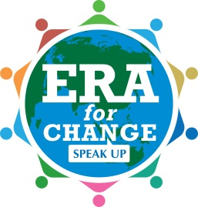
ERA For Change “Stella Fellas” and “Stella Bellas” Campaign

Each year, 1.2 million children are bought, sold, kidnapped or trafficked. They are sold in every country on earth, and forced to work, often in horrific conditions and including sexual slavery. Approximately 80 per cent of victims are women and girls, up to 50% are minors, and some are as young as 4 years of age.

In Australia, one woman is killed every week by a current or former partner, and Australian Police handle one domestic violence matter every two minutes. Up to 70 percent of women experience physical or sexual violence from men in their lifetime — the majority by husbands, intimate partners or someone they know, and women are most likely to experience violence than other groups in the society: 93% of victims were women, 3% youth and 4% elderly.

On August 21 this year, thousands of students from ERA For Change schools around Australia will take a stand for women and children everywhere, by committing to being "Stella Fellas" and "Stella Bellas". A Stella Fella or Stella Bella is a young man or woman who will stand up for women everywhere and ensure all are treated with dignity and respect. As a sign of this commitment, students will take part in a range of activities including wearing bow ties or white ribbons to school, wearing ERA For Change wristbands made by girls rescued from the human trafficking industry, taking the White Ribbon Pledge to never "commit, excuse, or remain silent about violence against women", and by sharing their actions on social media.

Through this campaign ERA For Change will partner organisations working to end Human Trafficking and Violence Against Women including ACRATH, Project Futures, White Ribbon and the SHE Rescue Home. We invite all members of our school communities to take part in the campaign, and together to ensure our next generation of young men and women live in a world where no-one's life is for sale, and where all are safe.
