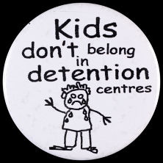 ADVOCACY- Human Rights
- How many human rights are there? _________________________________________________________
_______________________________________________________________________________________
- Who devised these human rights? __________________________________________________________
_______________________________________________________________________________________
TWO CLIPS TO WATCH: http://www.youthforhumanrights.org/
- History of Human Rights
- Where do human rights begin? _____________________________________________________________
_______________________________________________________________________________________
- Now Watch video # 14
So…it is a HUMAN RIGHT to seek asylum (HR # 14) and it is Human Right not to be detained unjustly or without good reason (HR #9)

The Government's latest statistics, dated 31 March 2015, reveal that:
- 124 children are held in immigration detention facilities within Australia;
- 103 children are held in detention on Nauru;
- 1,282 children are detained in the community under residence determinations, a system referrred to as community detention; and
- 2,760 children are living in the community on bridging visas which mean their parents generally have no work rights and very limited access to any Government support.
(Chilout.org)
Even ONE child in detention is too many.
List then different child rights that are broken when a child is held in detention on Nauru or Christmas Island?
ADVOCACY

What does the word advocacy mean? _____________________________________________________________
_____________________________________________________________________________________________
GIRL IN THE CAFÉ- WATCH THE FOLLOWING CLIP to 3:43:
- How is this character being an advocate? _____________________________________________________
_______________________________________________________________________________________
- What large and significant discrepancy did the lady point out at the dinner? ________________________
_______________________________________________________________________________________
- Where is there a discrepancy between HR # 14 and HR # 9 and the current Australian policy for asylum seekers who arrive by boat?
______________________________________________________________________________________________________________________________________________________________________________
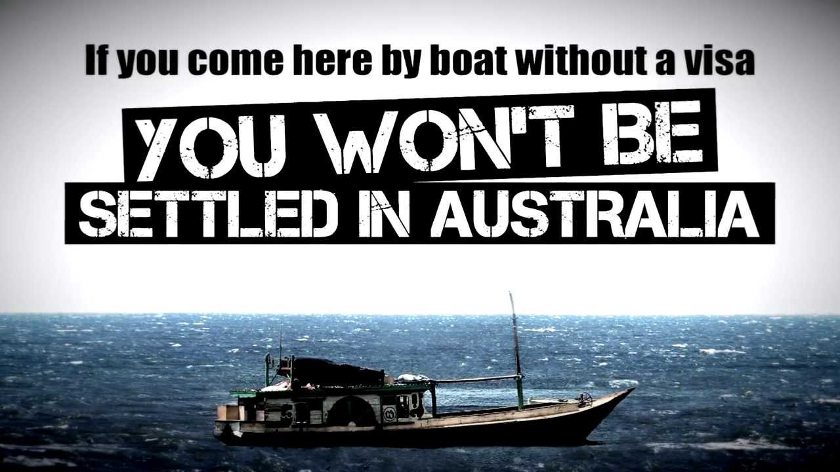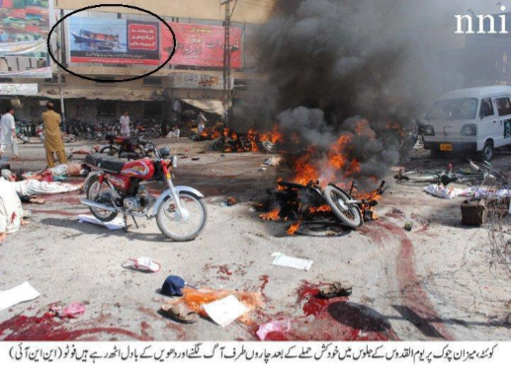

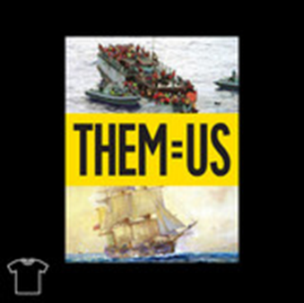
- Is there a discrepancy in the manner in which white Australia was founded and settled and the way the Australian government is currently treating people who are seeking life (not a better life…just life)
_____________________________________________________________________________________________________________________________________________________________________________________________________________________________________________________________________

The Weight of Nothing

“Tell me the weight of a snowflake,” a squirrel asked a wild dove.
“Nothing more than nothing,” was the answer.
“In that case I must tell you a marvellous story,” the squirrel said.

“I sat on a branch of a fir, close to its trunk, when it began to snow, not heavily, not in a raging blizzard, no, just like a dream. Since I didn’t have anything better to do, I counted the snowflakes settling on the twigs and needles of my branch. Their number was exactly 3,741,952. When the next snowflake dropped onto the branch---nothing more than nothing, as you say---the branch broke off.”

Having said that, squirrel scampered away. The dove thought about the story for a while and finally said to herself: “Perhaps there is only one person’s voice lacking for peace to come about in the world.”

Explain the underlying message of this poem: ________________________________________________________
__________________________________________________________________________________________________________________________________________________________________________________________________________________________________________________________________________________________
If you think of this story in the context of human rights, what are five things that you can regularly do that might break the branch….that might lead to a more just world?
- ______________________________________________________________________________________________________________________________________________________________________________
- ______________________________________________________________________________________________________________________________________________________________________________
- ______________________________________________________________________________________________________________________________________________________________________________
- ______________________________________________________________________________________________________________________________________________________________________________
- ______________________________________________________________________________________________________________________________________________________________________________

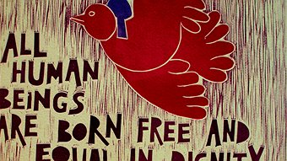
DETENTION 4 DETENTION: A very simple event
Students & staff voluntarily give themselves one lunchtime detention as an act of solidarity with the many children still being kept in detention under current government policy.
We need to sit or stand in silence for a short period of time in the Quadrangle
Participants can have material tied around the mouths of people participating and/or hands tied behind their back to represent the lack of voice and the vulnerability of these people.

